1.Create a table called Orders with columns: order_id, user_id, order_date, and total_amount. Insert at least 7 sample rows representing different users and dates, similar to how food orders appear in Zomato or Swiggy.

CREATE TABLE Orders (
order_id INT PRIMARY KEY,
user_id INT,
order_date DATE,
total_amount DECIMAL(10,2)
);

INSERT INTO Orders (order_id, user_id, order_date, total_amount)
VALUES
(1, 101, '2026-09-01', 250.00),
(2, 101, '2026-09-02', 400.00),
(3, 102, '2026-09-02', 150.00),
(4, 101, '2026-09-03', 350.00),
(5, 102, '2026-09-04', 600.00),
(6, 101, '2026-09-05', 100.00),
(7, 102, '2026-09-06', 300.00);

2.Write a SQL query using the LAG() function to show each user's order_id, order_date, and the total_amount of their previous order (if any), ordered by user and date.<br><br><em><strong>Hint:</strong> Use PARTITION BY user_id and ORDER BY order_date in your window function.</em>

SELECT
user_id,
order_id,
order_date,
total_amount,
LAG(total_amount) OVER(PARTITION BY user_id ORDER BY order_date) AS previous_amount
FROM Orders;
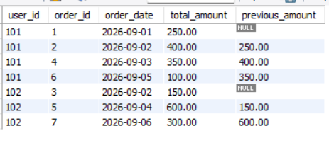

3.Using the same Orders table, write a SQL query with the LEAD() function to display each order_id, order_date, and the next order's total_amount for the same user.

SELECT
user_id,
order_id,
order_date,
total_amount,
LEAD(total_amount) OVER(PARTITION BY user_id ORDER BY order_date) AS next_amount
FROM Orders;

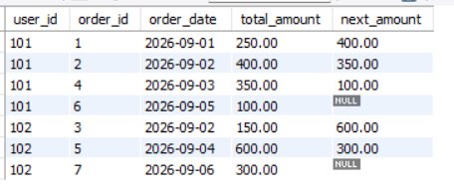

4.Write a SQL query to calculate the running total of total_amount for each user, showing order_id, order_date, total_amount, and a column running_total that accumulates the sum as you move through each user's orders.<br><br><em><strong>Hint:</strong> Use SUM(total_amount) OVER (PARTITION BY user_id ORDER BY order_date ROWS BETWEEN UNBOUNDED PRECEDING AND CURRENT ROW).</em>

SELECT
order_id,
order_date,
total_amount,
SUM(total_amount) OVER (
PARTITION BY user_id
ORDER BY order_date
ROWS BETWEEN UNBOUNDED PRECEDING AND CURRENT ROW
) AS running_total
FROM Orders;

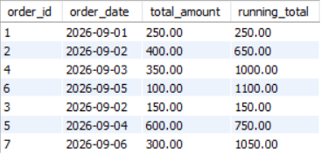

5.Write a SQL query to calculate a 3-order moving average of total_amount for each user, showing order_id, order_date, total_amount, and moving_avg columns.<br><br><em><strong>Constraint:</strong> Use SUM() OVER() with ROWS BETWEEN 2 PRECEDING AND CURRENT ROW to compute the moving average.</em>

SELECT
order_id,
order_date,
total_amount,
SUM(total_amount) OVER (
PARTITION BY user_id
ORDER BY order_date
ROWS BETWEEN 2 PRECEDING AND CURRENT ROW
) / 3 AS moving_avg
FROM Orders;

